Snowflake CLI – Homework / Play Tasks
1.Basic CLI Usage
CLI (Command Line Interface)
CLI is a command line program that accepts text input to execute operating system functions.
- Check the Snowflake CLI version.
snow –version
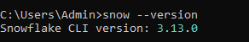
- Add connection to Snowflake using the CLI.
snow connection add
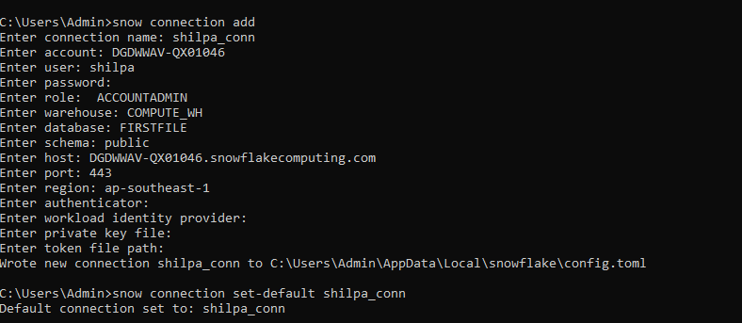
- Test connection to Snowflake using the CLI.
snow connection test
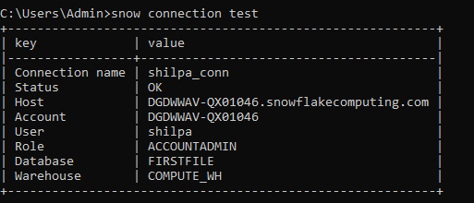
- 2. Running Simple SQL
Run a SQL command to show all databases.
snow sql -q "SHOW DATABASES;" 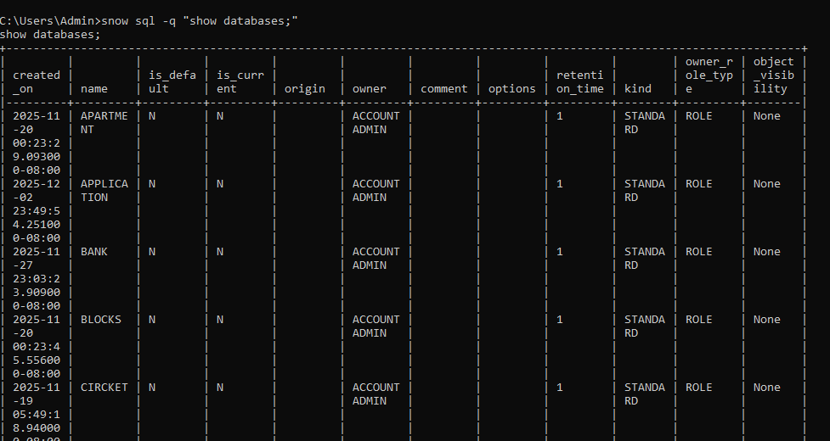
- Run a SQL command to show all warehouses.
snow sql -q "SHOW WAREHOUSES;" 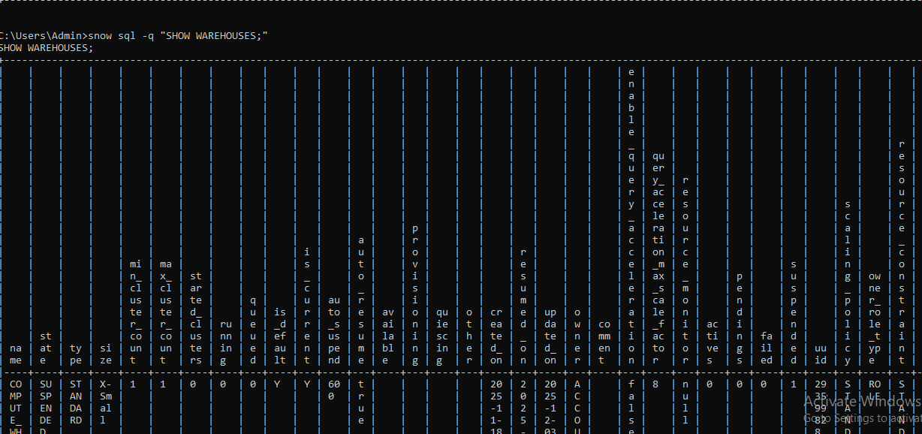

- Run a SQL file using the Snowflake CLI.
snow sql -f C:\Users\Admin\Downloads\test_script.sql
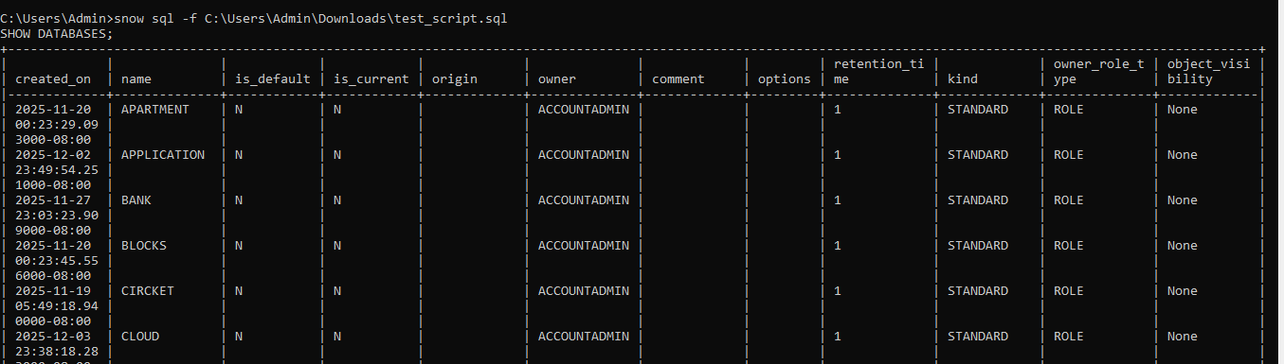

- 3. Creating Objects
- Create a database using the CLI.
snow sql -q "CREATE OR REPLACE DATABASE MY_NAME;"
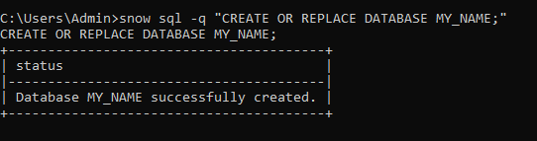
- Create a schema inside that database.
snow sql -q "CREATE OR REPLACE SCHEMA MY_CONN;"
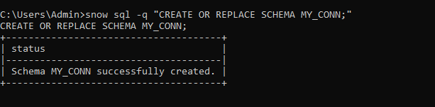

- Create a table using a SQL file and run it through the CLI.
snow sql -f C:\Users\Admin\Downloads\test_script.sql

CREATE OR REPLACE TABLE EMP (
ID INT,
NAME STRING,
DEPT STRING,
EMAIL STRING
);
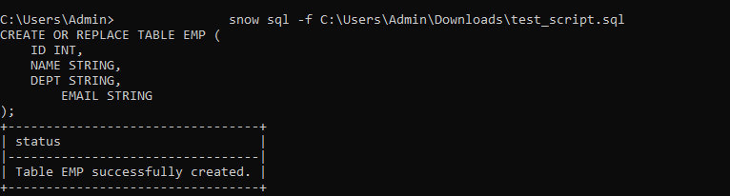

- 4. Working With Stages
- Upload a small CSV file to an internal stage using the CLI.
snow sql -q "put file://C:/Users/Admin/Downloads/employee/employee1.csv @mystage;"
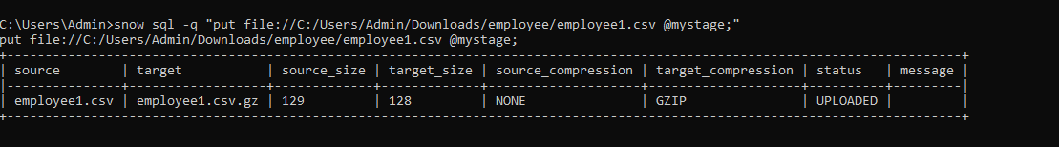
- List the files inside the stage.
snow sql -q "list @mystage;"
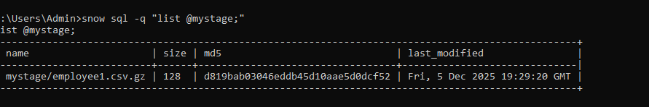
- Download the uploaded file back to your computer.
snow stage copy @mystage/employee1.csv "C:\Users\Admin\Downloads\employee_downloaded.csv"
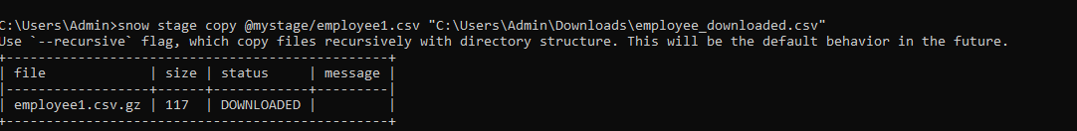

- 5. Loading and Unloading Data
- Load CSV data into a table using COPY INTO via the CLI.
snow sql -q "COPY INTO EMP FROM @mystage FILE_FORMAT = (TYPE = CSV FIELD_DELIMITER = ',' SKIP_HEADER = 1) ON_ERROR = 'CONTINUE';"

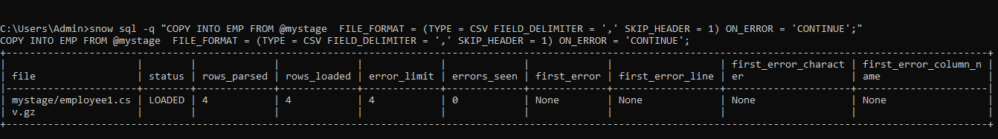
- Unload data from a table into a stage.
snow sql -q "COPY INTO @mystage/employee_unload/ FROM EMP FILE_FORMAT = (TYPE = CSV FIELD_DELIMITER = ',');"

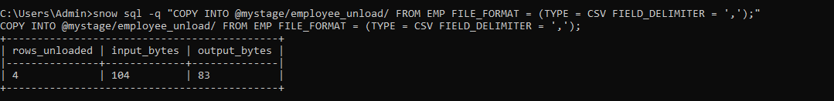

- 6. Deploying a Snowflake Project

- Initialize a Snowflake project using snow init.

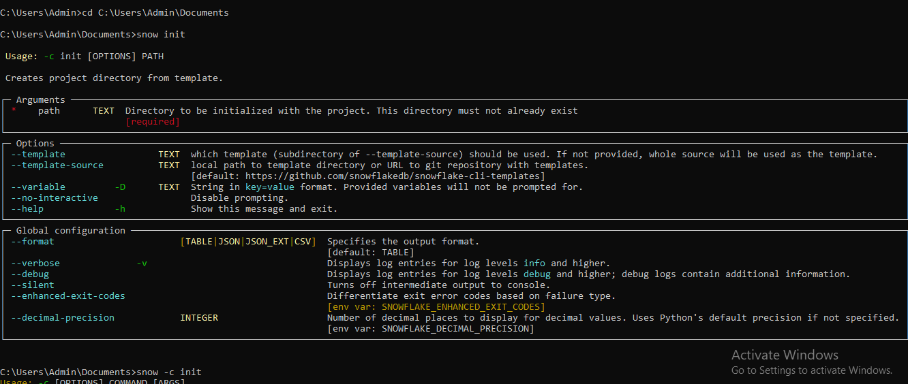

- Deploy the project using snow deploy.

- 7. Query Output Practice
- Run a SELECT query and save the results to a CSV file using the CLI.
snow sql -q "SELECT * FROM EMP;" > C:\Users\Admin\Downloads\emp.csv
- Try different output formats such as pretty, CSV, and JSON.
snow sql -q "SELECT * FROM EMP;" > C:\Users\Admin\Downloads\emp.txt
snow sql -q "SELECT * FROM EMP;" > C:\Users\Admin\Downloads\emp.json
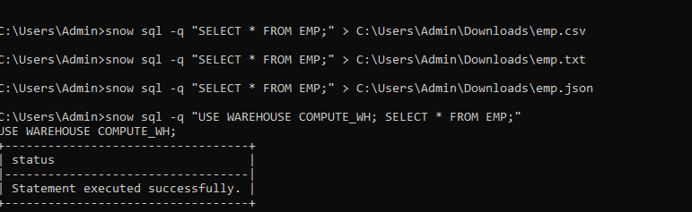

- 8. Playing With Context
Change the warehouse while running a query.
snow sql -q "USE WAREHOUSE COMPUTE_WH; SELECT * FROM EMP;"
COMPUTE_WH is simply the default warehouse name many accounts use
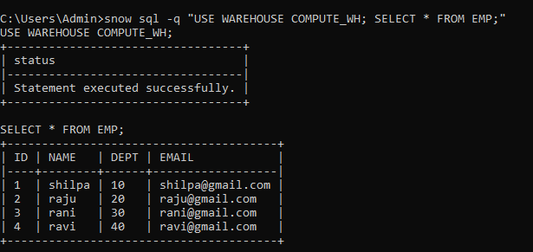

Change the database and schema using CLI options.
snow sql --dbname PERSONS --schemaname PUBLIC -q "SELECT * FROM PERSONS;"

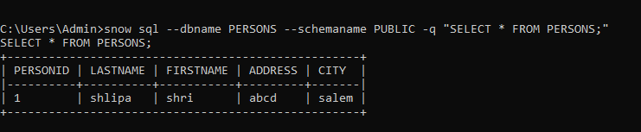
- 9. Troubleshooting and Help
Use the help command to list all available CLI commands.
snowsql –h
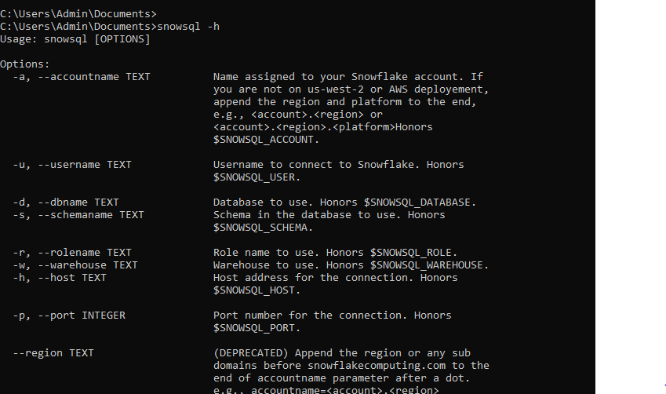
Run a command in verbose mode to view detailed logs.
set SNOWFLAKE_CLI_LOG_LEVEL=DEBUG
snow sql -q "SELECT CURRENT_TIMESTAMP();"
